**Function Pointer assignments**

**Mandatory**

**1. WAP to invoke functions below based on user input character using function pointer. Character mapping and respective functions to be invoked are given below.**

**Character input Function**

**+ int add(int x, int y)**

**- int sub(int x, int y)**

**\* int multiply(int x, int y)**

**/ int divide(int x, int y)**

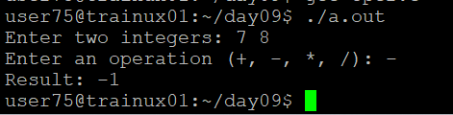

**2. Extend Q1 to include a function below which will return the address of a function based on input character.**

<address of function> getaddr(char mychar);

**3. Extend Q1 to include a function below which takes a function pointer to a calculator function and one integer (value = 10) as arguments and shall invoke the given function with required arguments. For the second argument read input from user. Return the result.**

int invokefunc(<function pointer as argument1>, int val1);

**4. Extend Q1 to define an array of function pointers and invoke them based user input character.**

